To access the main menu, tap the Contacts button found on the first screen.

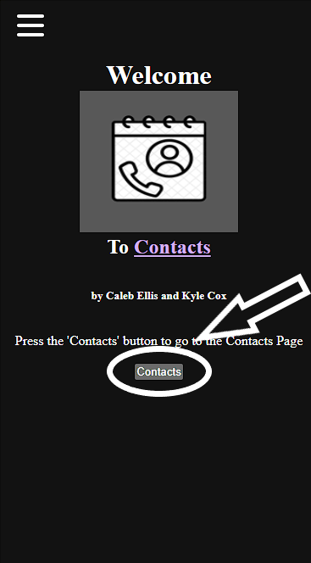

After you tap the button, you should be on this screen.

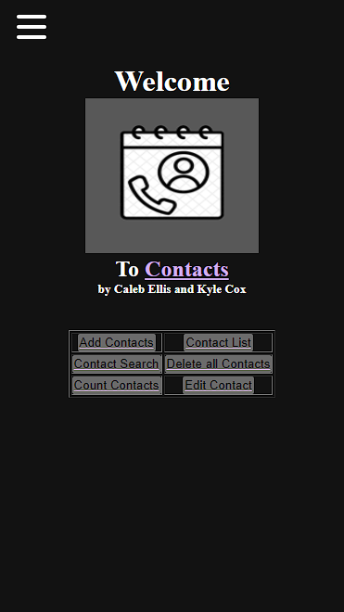

To add a contact, first press the “Add Contact” button on the menu page.

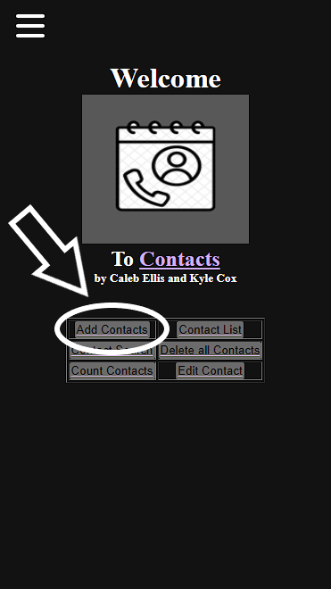

When the “Add Contact” is pressed, you should see this page. Fill out all text fields and then click Save

When the save button is clicked, you will see this prompt to let you know that your contact has been saved successfully

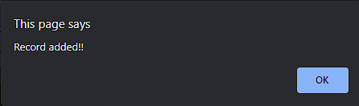

To go back to the Menu or to navigate the app for more options, just press the word “Contacts” that is in purple font or click the hamburger menu on the top left. You can tap the “Reset” button to clear all text fields

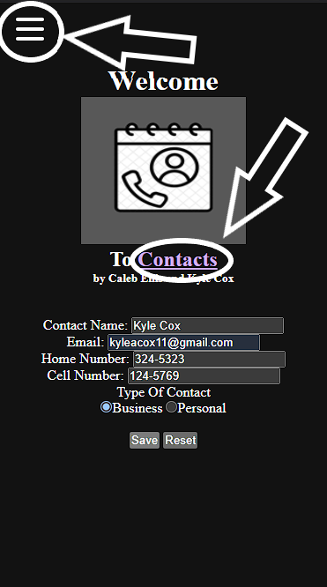

To see your contact list, tap the button found in the main menu called “Contact List.”

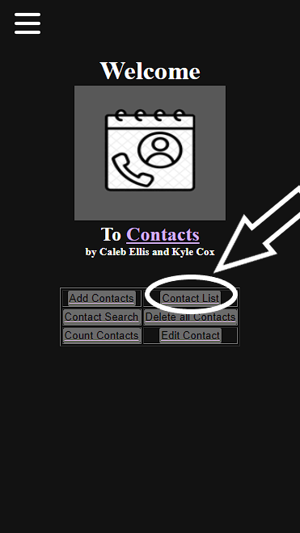

Afterwards you should see a screen that looks like this with all your contacts that you saved.

.

To search for a contact, first press the Contact Search button in the main menu.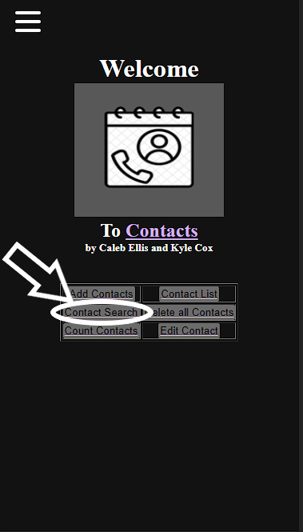

Next, you will be on this screen that has a drop-down box with all your contact names.  
Select the contact’s name you want to search then tap the “Search” button.

When you click “Search” you will be on a screen looking like this.

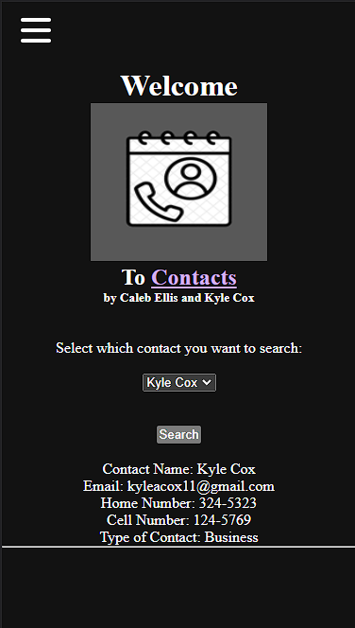

To delete all contacts first press the “Delete all Contacts” button in the main menu.

After you pressed the “Delete all Contacts” button on the main menu you should be brought to this screen. Tap the “Delete” button to finalize the deletion.

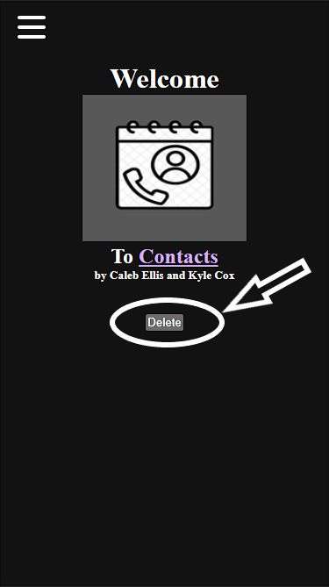

To see the number of contacts that you have, press the “Count Contacts” button found in the main menu screen.

The next screen will display your number of contacts.

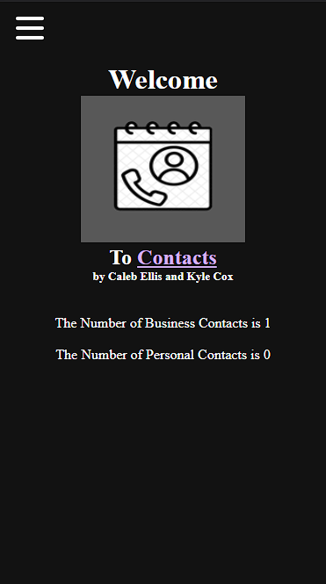

To edit any contact that its saved, first press the “Edit Contact” button on the main menu.

When you are brought to this screen, first select the contact’s name you want to edit in the drop-down box. Then type information into all of the text fields. Lastly press “Save” button. You can tap the “Reset” button to clear all text fields.

